Executive Summary

Business Situation:
XXX is a Fortune 500 Property Insurance Mutual Company. We have 50+ products/applications that are used internally by our Field Engineers and externally by our Brokers and Clients. These applications would encounter some or other incidents/faults that would need attention from different departments for quick resolution. Often, these issues would occur at any time of the day. This requires multiple people from all the teams to be on call, ready to respond within a pre-defined Service Level Agreements (SLA) i.e. most importantly, accessible to their laptops and internet. We have a centralized ticketing system where all production incidents get logged, tracked, worked upon with proper resolution and brought to closure.

Problem Statement:
Our SLA’s are generic and defined by environments where the incidence occurs. Production down situations get highest priority and get resolved swiftly. Anything non-production, will have an owner team that will work with multiple other teams to bring an issue to closure. The timelines for such activities are dependent on how busy the team is, do they have the same urgency to solve the problem, dependencies among other teams to help with root cause analysis and resolution, business processes to be followed, etc. All of this leads to inefficiencies, piling up of tech debt and indirectly impacting our ability to deliver quality projects on time.
While every team has access to their incident report, they also own process efficiency. The intention of this report is to highlight few such opportunities for improvement, process gaps that is taking too long for easily achievable outcomes and what realistic SLA’s should be set for resolution. This report should also provide insights into how efficiently we are using our team members to solve most important problems and see opportunities ahead of us.

Analysis Approach:
The entire dataset has 600,000+ records with around 100 columns. Analyzing such a large volume data was challenging for the tools and algorithms we are using and not giving an actionable insights. So, I decided to do this analysis is on a small sample set from the data dump for most critical business applications. Global Business System (GBS) and RATS were among the top applications that had most number of tickets requiring manual intervention. As we are a large organization with offices spread across the globe, it was important to know if these issues were reported only from a specific region or country. Following the same count-based ranking, I picked our Boston Operations as its very active for the number of clients it supports, and it also came out to be one of the top locations to report incidents.
I used tableau and database queries to condense the dataset. With the help of R as a programming language and decision tree based predictive algorithm, we analyzed how long does it take for an issue to be resolved.

Key Recommendations and Observations:
- Invoicing related issues are most common from boston operations team.
- GBS has highest number of incidents reported. Possible opportunity for deeper analysis, self-servicing or better failure management processes to be in place.
- Generating a new document takes more than 54 days. Opportunity to reduce this timeline.
- SLA’s for Invoicing issues vary from 0 to 54 days.
- Almost 70% of GBS issues are resolved in less than 8 days. Is this SLA acceptable to the operations team.

Analysis

Inspiration for this project:
As a Technology Manager, I witness lot of inefficiencies and lack of resource utilization across different delivery teams. Often, the product leadership focus is on releasing new features to wow the customers. While chasing for the next shiny object, we often incur lot of tech debt and sacrifice on quality of our deliverables. Operational processes that were setup decades ago, don’t make sense anymore. The intention of this report is to create awareness on product improvement by analyzing historical incident data to help make the right investments for product maturity.

Parallel effort to assess health of an application:
Recently, I am involved in a parallel effort to create PowerBI dashboards as seen in Figure 1 and 2 for understanding how well a product is doing based on the number of issues being reported by the users. The scope of that project is limited to showcasing incidents to a product stakeholder. It doesn’t address the problem statement I have highlighted in this report.

Approach to solve the Problem:
Below is a brief approach I used to come to the recommendations and conclusion:
- Volume of data:
The complete dataset from our incident management platform consisted of 630,000 records with 100+ columns spread across last seven years. As I didn’t have the data dictionary readily available, it took me sometime to understand how the data is structured. The PowerBI reports mentioned above, definitely helped gain basic understanding of the data. But, it was catered for different audience to drive a disparate outcome.
- Data Discovery:
  - I started identifying all the important columns that made sense to be included in my analysis. This activity helped me reduce the dataset to 14 columns. Being a Software Engineer in past, I used SQL Server Management Studio to query the backend data and help understand the data due to lack of data dictionary.
  - All across my use of R, I had always worked on excel or csv files. Connecting with a live database was something I had never done before. But, the R community forums helped me establish this connectivity with Windows authentication. My backup plan was to dump this dataset in excel/csv and work from there.
  - Next, I tried to identify the right datatype for all these columns. I was able to classify all the data columns across factor, integer and date datatypes.
  - Recollecting from my past Business Analytics classes, I also realized that I need to change null values to ‘NA’ or ‘0’ based on the datatype as R cannot understand null values.
  - Creating a full classification tree was a big hurdle that I had to overcome. I initially started with entire 630k records and 14 variables to soon realize that this data was too big for R to host. I would frequently get out of memory exception. I tried to reduce this dataset to smaller samples of 100k,50k,10k,5k and finally to 1000 records. This seemed more manageable for R. I had to somehow be at peace with this volume for further analysis even though I had 600 times more data to feed in to improve the accuracy of my prediction.
  - Next challenge was to create full classification tree. Even with 1000 records, my code execution would not proceed. Upon checking with the professor, I was told that having too many factor variables with 10+ levels would not work in R.
  - I started working back on the sample data to eliminate ‘category’ variables by using them as filter for getting ‘GBS’ and ‘RATS’ specific incidents. A quick tableau analysis shown in Figure 1 helped drive this conclusion.
  - Another filter criteria worth using was ‘Customer Location’ set to ‘Boston Office’ concluded using Tableau worksheet as seen in Figure 2. This helped me analyze a narrow dataset with three dependent variables from my original list of 14. After fixing my dataset, I had to change my target variable from ‘category’ to ‘sub category’. The entire R code is placed in Google drive folder in Link 1.
- Extrapolating recommendation from the analyzed dataset.
  - Invoicing as a major subcategory was an outcome from classification tree. A further analysis in Tableau as seen in Figure 3 just validated this finding.
  - Referring to Figure 1, GBS has the highest count of incidents at 44,569.
  - If you look at the classification tree plot from File 1, it shows that document generation issues take more than 54 days to resolve, making it one of the highest subcategory for open issues.
  - Again, navigating through classification tree, we can observe that 351 out of 499 invoicing issues are resolved within 8 days. Does this meet business expectation? Are the SLA’s aligned with this observation.

Appendix:
File 1: Classification Tree output from R
File 2: R code for classification tree
Figure 1: Tableau worksheet for Category with highest incidents
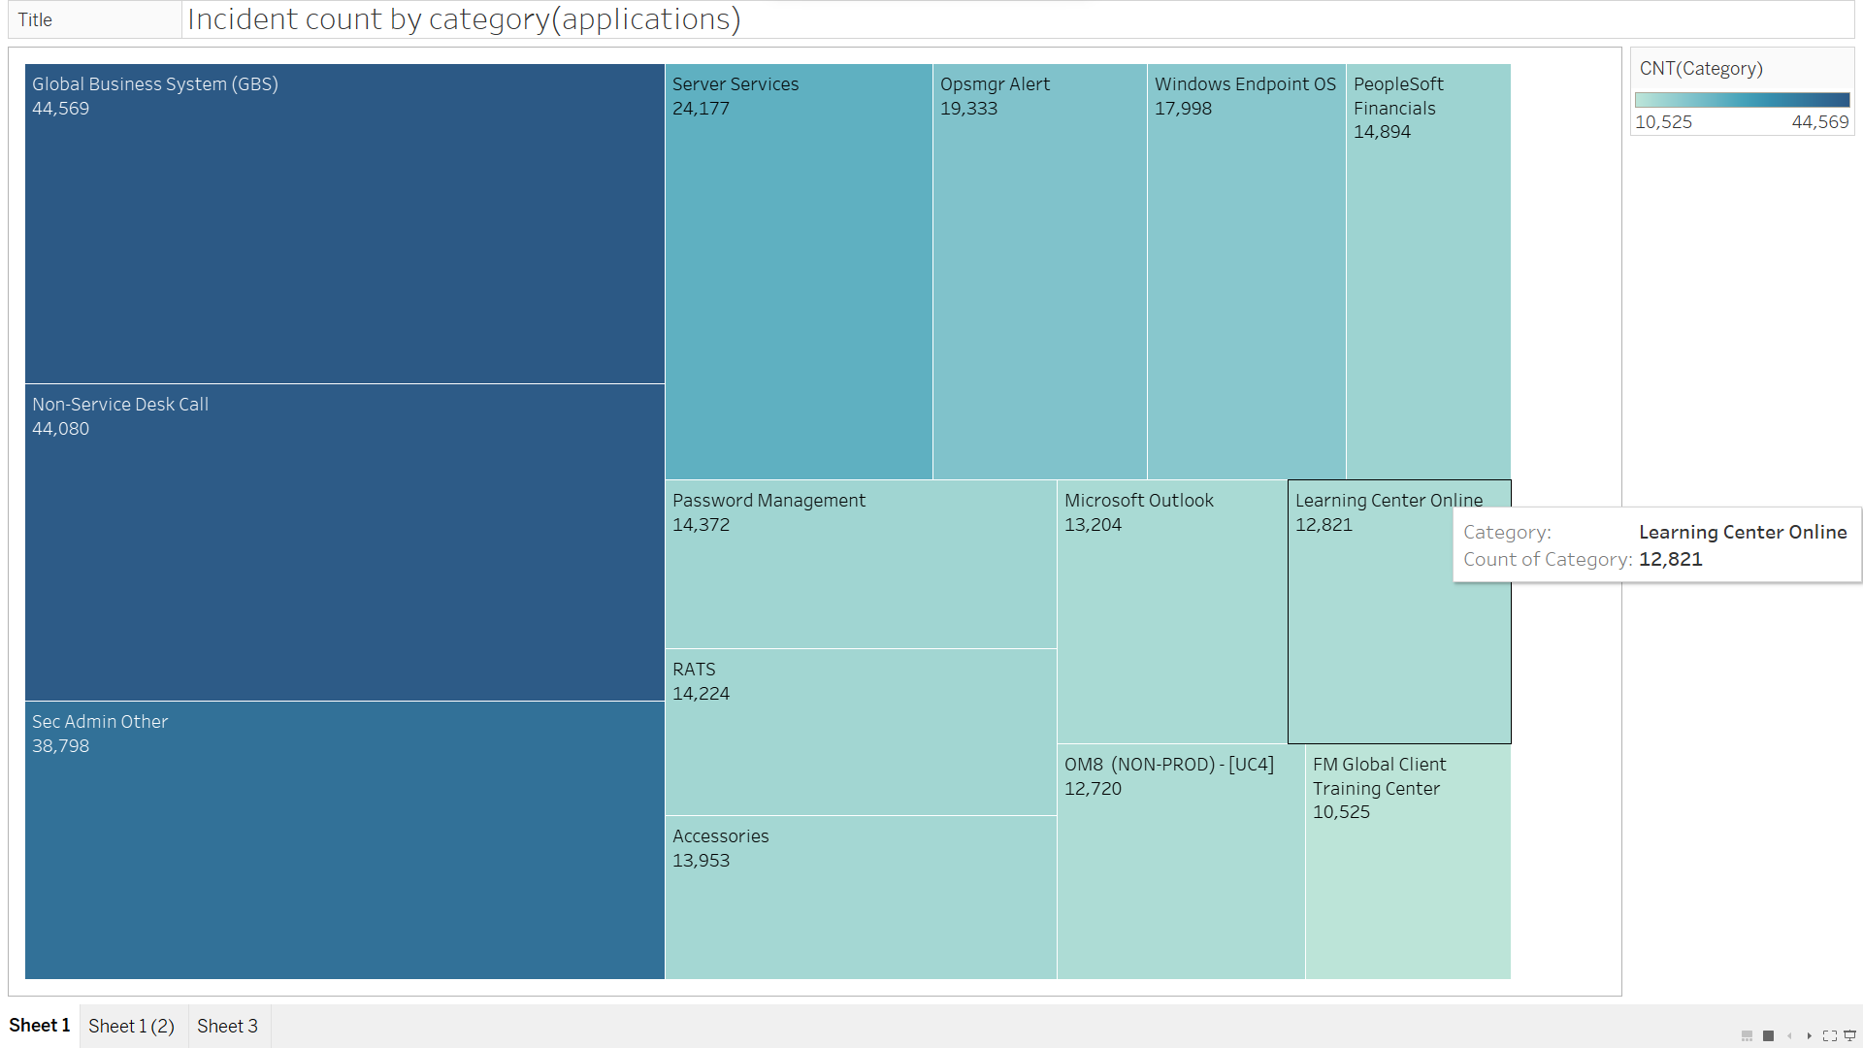
Figure 2: Tableau worksheet for customer locations with highest incidents
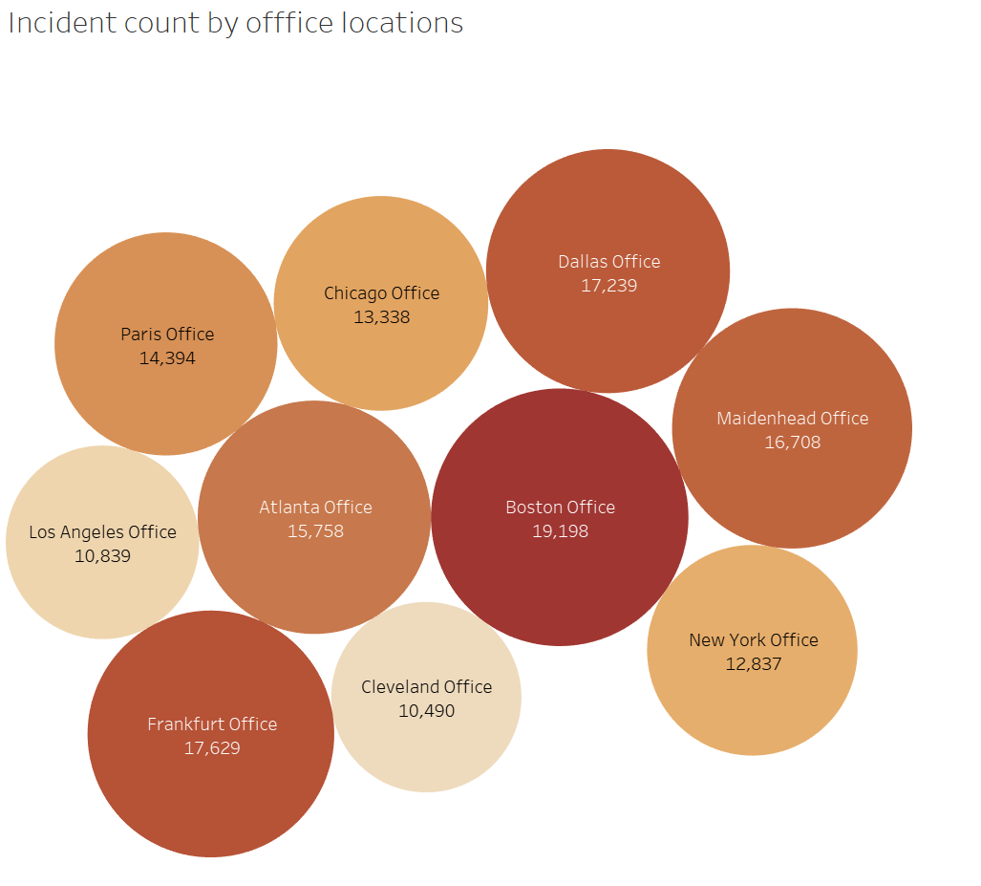
Figure 3: Tableau worksheet for Subcategory counts for ‘GBS’ and ‘RATS’

